# Lab Exercises

## 

## Exercise 1: Look Deeper into Crown's Website

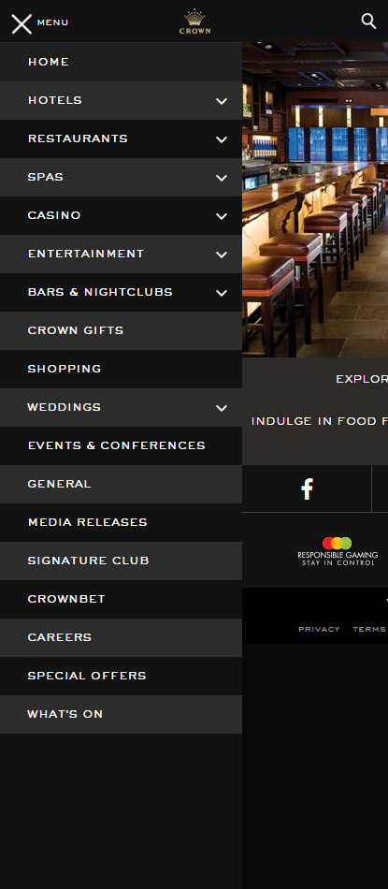

In this week’s tutorial you will be covering the restaurant areas of the Crown Casino Website. We recommend that you explore Crown's website further, in particular the "Hotels and Spas" and the "Bars and Nightclubs" areas.

Look at how they have segmented each area (usually premium v/s budget-conscious) and examine how they appeal to a broad range of audiences before directing them to content-specific pages.

The website content can also be accessed through the expanding menu (shown right), accessible on the top left corner of the website.

How are these links organised? With particular audiences in mind or does it have more of a "site-map" layout?

Ans: The link arranged by having its signature services that customers expected it to offer (hotels, restaurant, casino, spa” at the top which most likely for high class users. Following that is the place that most users frequent like gifts, shopping for casual customer. After that are higher scale services like conferences or wedding. Lastly is information regarding this website and its job offer for those who wants to work here.

## Exercise 2: Examine RMIT's Brand Guideline Document

Open the RMIT brand guideline document which guides all RMIT users when creating publications:

[[ document is in the week 4 WP Public folder ]]

How many fonts are you allowed to use in RMIT official publicity materials?

Ans: 3 types. Museo (Primary) , Helvetica Neue (Secondary typeface) and Arial (System typeface)

RMIT seems to allow unlimited color choices. Is this true? (Hint: look for "primary" and "secondary" colour palettes)

Ans: No. RMIT has its own primary colors which are red, blue

RMIT seems to allow unlimited "children's block" graphical elements. Is this true? (Hint: look for "Pixel shapes")

Ans: No. Too much or too little will cause an unbalance in the overall design. (More specifically, only 2 pixel shapes maybe used per view)

How restricted is the use of the RMIT Coat of Arms?   
**Update**: very restricted, no longer in the Brand Guidelines!

When designing your wireframes, mockups and style guides in your assignment, consider:

* Which fonts and sizes are you using, have you specified where each is allowed?
* Is your palette of colors (hues and shades) too limited or too diverse? Where can each be used?
* Have you listed all icons or iconic shapes which fit with the client's brand?
* Is it clear to another developer what things you can and can't do?